Git and Flask Assignment Submission

Student Details
Name: Mustafizur Rahman
GitHub Username: Mustak22
Repository Link:
https://github.com/Mustak22/flask-todo-project

Task 1: Repository Creation and Branch Merge

Objective
Create a GitHub repository, clone it using SSH, create a user branch, add Flask project files, and merge them into the main branch.
Step 1: Generate SSH Key
Command:
ssh-keygen -t ed25519 -C "mustafizur.rahman17@gmail.com"
Explanation:
Generated a new SSH key pair for secure authentication with GitHub.
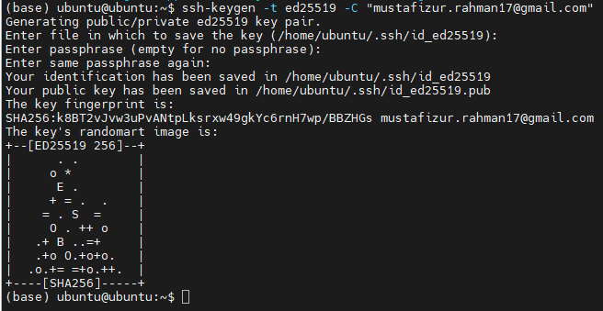

Step 2: Add SSH Key to GitHub
Command:
cat ~/.ssh/id_ed25519.pub
Explanation:
Copied the public SSH key and added it to GitHub → Settings → SSH and GPG Keys.
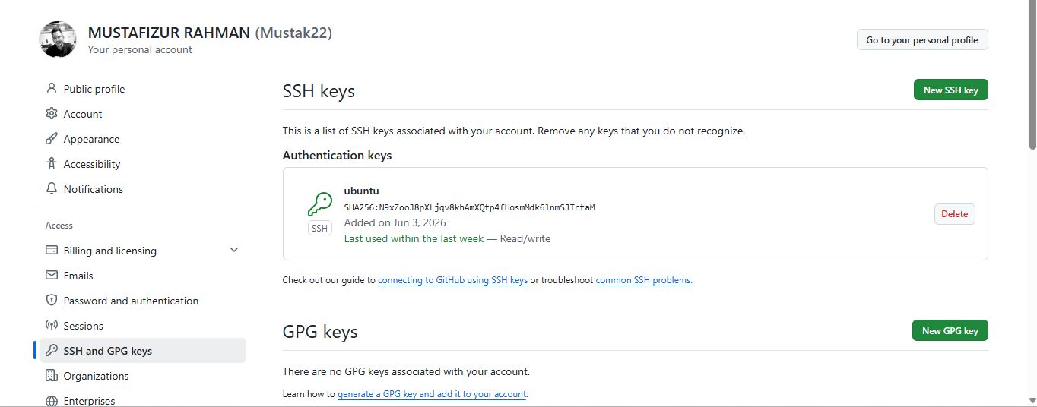

Step 3: Clone Repository
Command:
git clone git@github.com:Mustak22/flask-todo-project.git
cd flask-todo-project
Explanation:
Cloned the repository to the local machine using SSH.
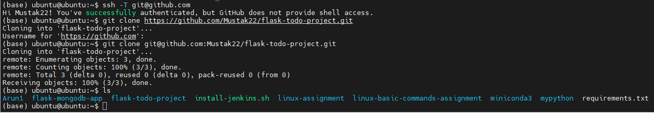

Step 4: Create Username Branch
Command:
git checkout -b Mustafizur
Explanation:
Created a new branch named Mustafizur.
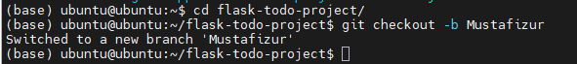

Step 5: Add Flask Project Files
Command:
git add .
git commit -m "Added Flask project files"
git push origin Mustafizur
Explanation:
Added Flask project files, committed them, and pushed them to GitHub.
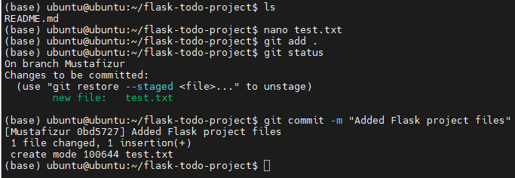

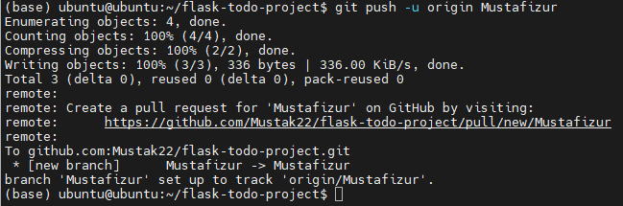

Step 6: Merge Branch to Main
Command:
git checkout main
git merge Mustafizur
git push origin main
Explanation:
Merged the Mustafizur branch into the main branch.
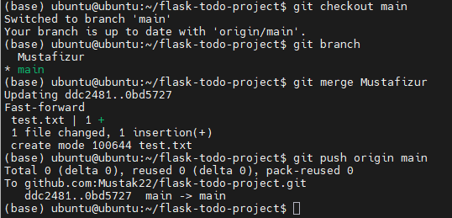

Task 2: Update JSON File and Resolve Merge Conflicts

Step 1: Create Branch
Command:
git checkout -b Mustafizur_new

Step 2: Update JSON File
Updated info.json:
{
"name": "Mustafizur Rahman",
"role": "DevOps Engineer",
"location": "Benglore Assam India"
}

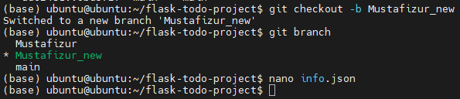

Step 3: Commit Changes
Command:
git add .
git commit -m "Updated JSON data"
git push origin Mustafizur_new

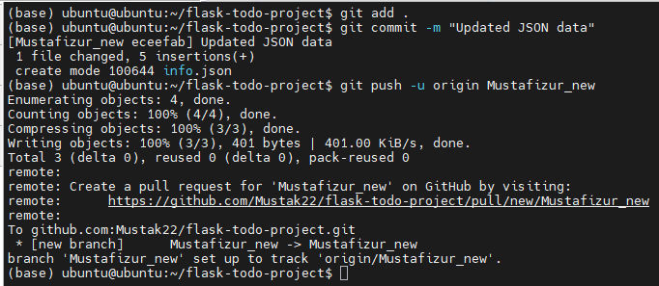

Step 4: Merge into Main
Command:
git checkout main
git merge Mustafizur_new

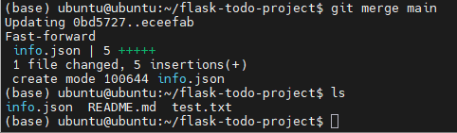

Step 5: Resolve Merge Conflict
Command:
git checkout --theirs info.json
git add info.json
git commit -m "Resolved merge conflict"
git push origin main
Explanation:
Accepted the version from Mustafizur_new branch and completed the merge.
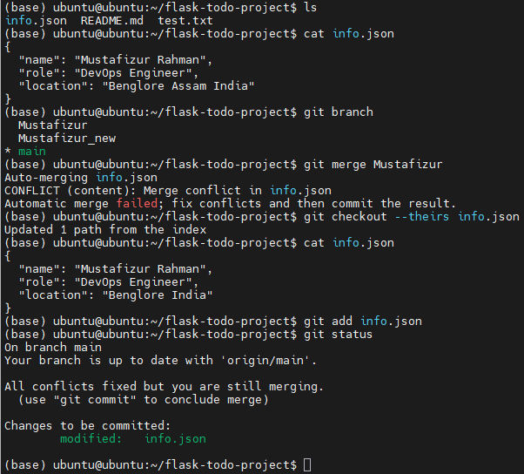

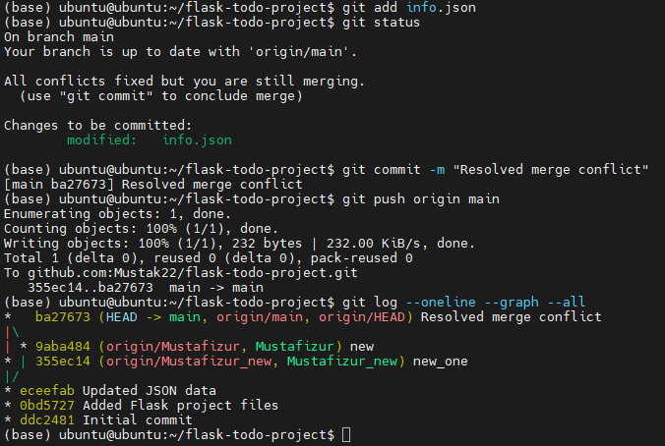

Task 3: Frontend and Backend Development

Create Branches
Command:
git checkout -b master_1
git checkout main
git checkout -b master_2

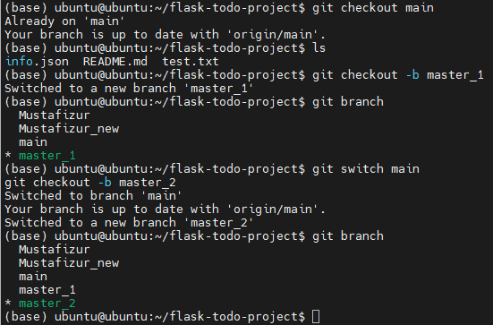

Frontend Development (master_1)

ToDo Page
Fields:
- Item Name
- Item Description
Commit:
git commit -m "Created ToDo page"

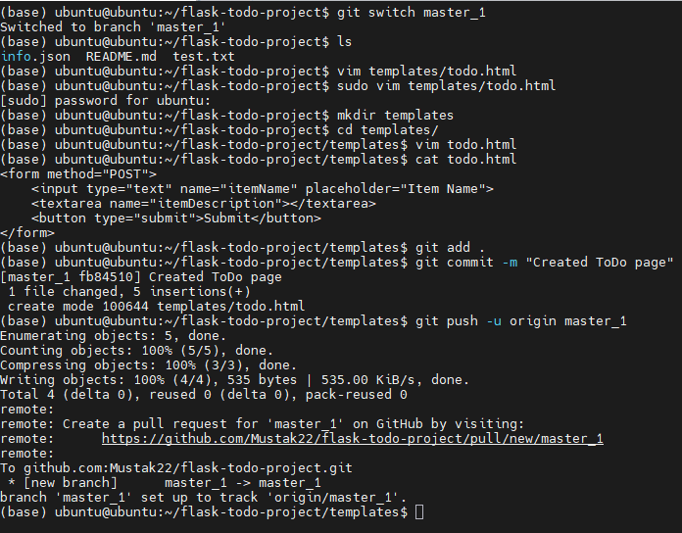

Backend Development (master_2)

/submittodoitem Route
Commit:
git commit -m "Added submit todo API"

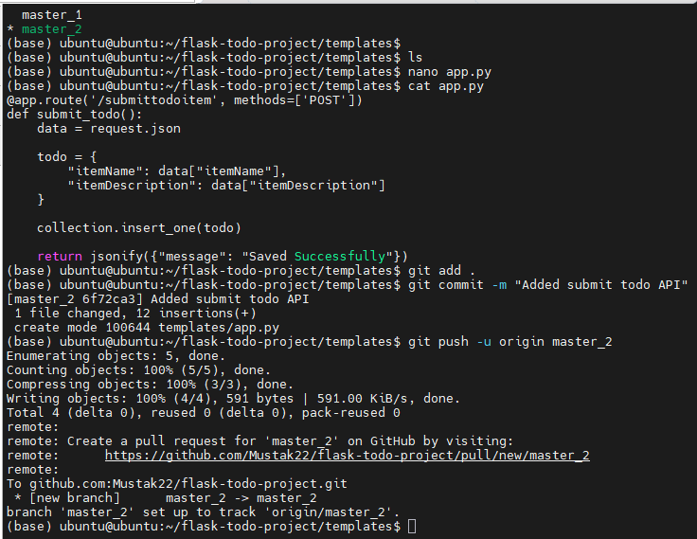

Merge Both Branches
Command:
git checkout main
git merge master_1
git merge master_2
git push origin main

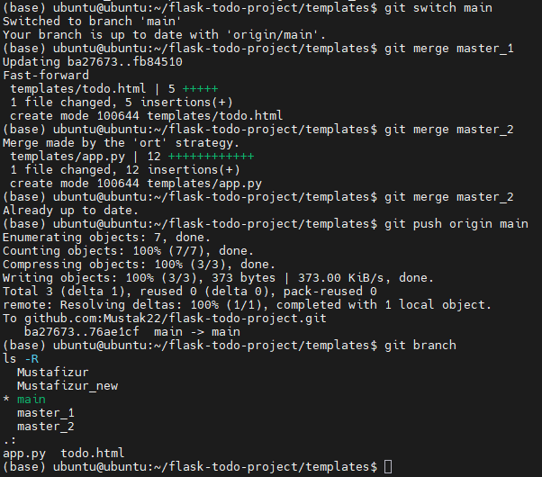

Task 4: Sequential Commits and Git Reset

Commit 1 – Add Item ID
Commit Message:
git commit -m "Added Item ID field"

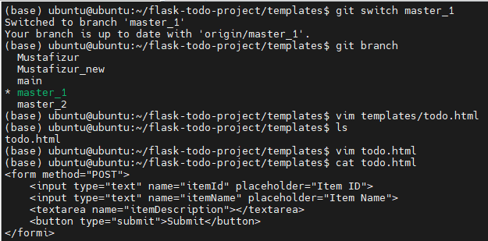

Commit 2 – Add Item UUID
Commit Message:
git commit -m "Added Item UUID Field"

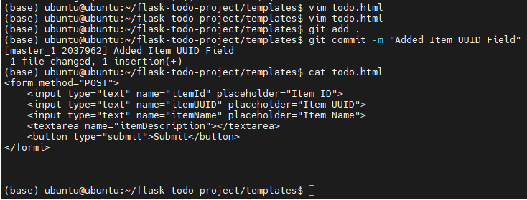

Commit 3 – Add Item Hash
Commit Message:
git commit -m "Added Item Has Field"

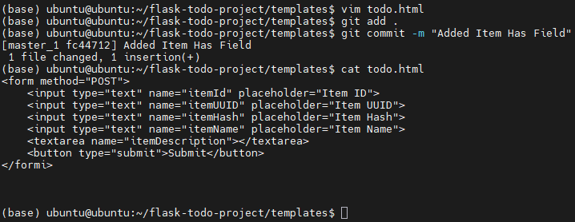

Merge master_1 into Main
Command:
git checkout main
git merge master_1
git push origin main

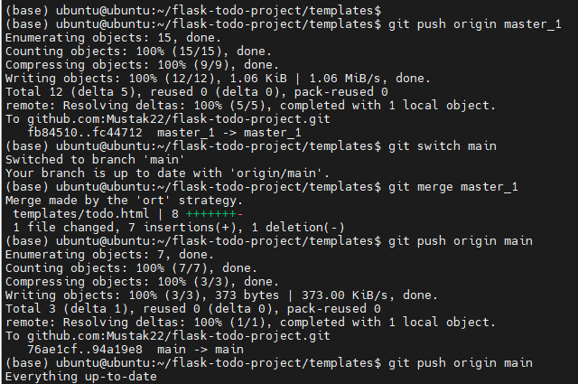

Git Reset
View Commit History:
git log --oneline
Reset Command:
git reset --soft 3e5c52d
Explanation:
Rolled back to the commit where only Item ID field existed while keeping changes staged.
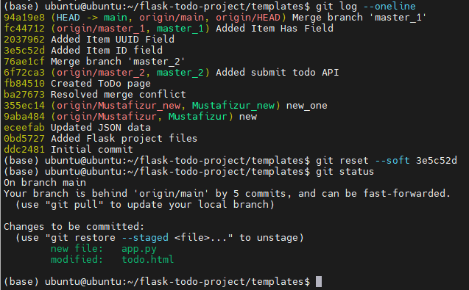

Re-Commit
Command:
git commit -m "Reverted to Item ID state"
git push origin main --force

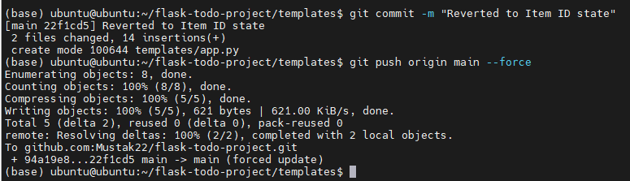

Rebase
Command:
git checkout master_1
git rebase main
Result:
Conflict occurred in:
templates/todo.html

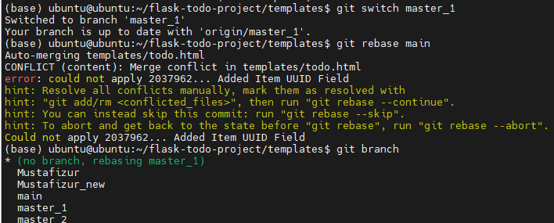

Final Verification
Commands:
git branch
git log --oneline --graph --all

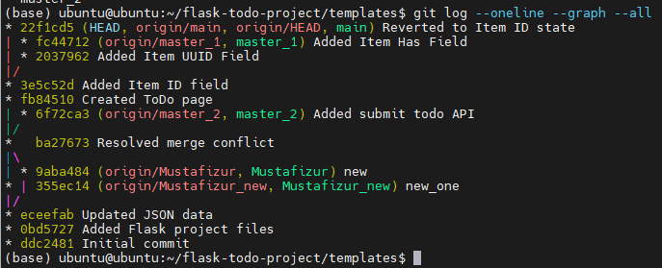

GitHub Repository:
https://github.com/Mustak22/flask-todo-project

